**Assignment-10(Mongo dB)**

Northwest Missouri State University is one of those universities that strive for student development and success. In this process, Northwest is organizing a few workshops regularly for students in different sectors.

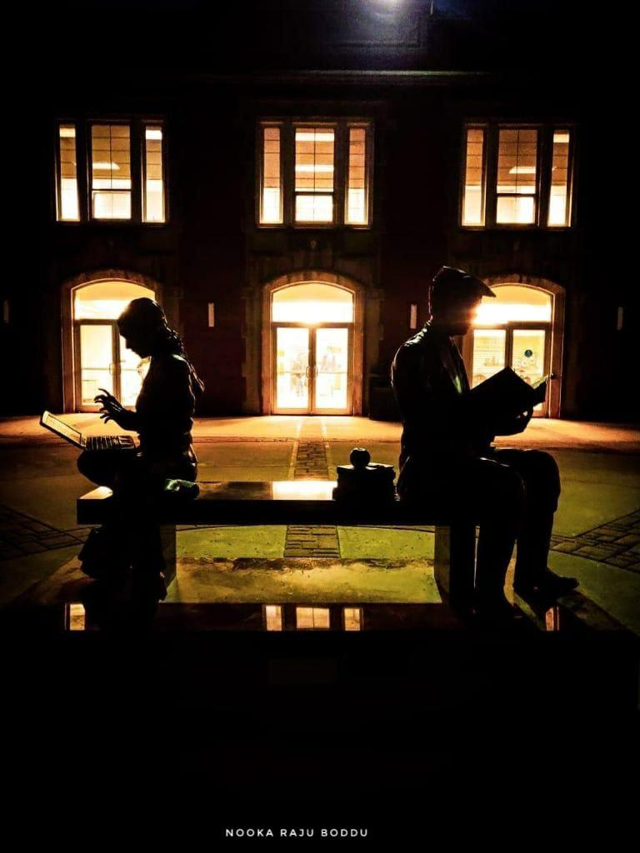

So let’s imagine the list of a few workshops that they have decided to conduct in the year 2020 as shown below.

|  |  |  |  |
| --- | --- | --- | --- |
| **Name** | **Location** | **Duration (in hours)** | **GuestList** |
| Agro Development | Library | 2 | Dr. Jennifer Cervantes, Dr. L. Hubbard |
| Future planning | Zoom | 1 | Dr. Chi Lo Lim |
| CAD training | SU | 3 | Dr. Damon Leiss, Dr. David Kiene |
| International Culture Exchange | Library | 2 | Dr. David Kiene, Dr. Joy Daggs, Dr. Shandy Beck |
| Technical talk | SU | 4 |  |
| Political talk | Zoom | 2 | Dr. Matt Schieber |
| Financial Planning | SU | 3 | Dr. Rick Toomey, Dr. Cari Cline |
| Healthy food | Zoom | 2 |  |
| Photography talk | Library | 1 | Dr. Roger Von Holzen |
| Fitness club | Gym | 3 | DR. Lori Mardis, Dr.Ildiko Olasz |
| VidGrid Training | CITEite Office | 2 | Dr. McDonald Gary |

The list is still incomplete and many changes may be required. But at this point, we have to store this data using the Mongo database.

**Questions:**

1. Firstly create a new database named “NorthwestWorkshops”.
2. Now write a query to create a collection to store the documents and name it as “workshops”.
3. Now write a query to insert the first record from the table given in the table above.
4. Now write a query to insert the rest of the data using only one command.
5. Now write a query to display the data using a single command.

Note: we have a method called pretty(), by which we can see the data in a better structure. Please use it.

1. Write a query that prints the names of all the events conducted through “Zoom”.
2. You can see that workshop named “Technical talk” does not contain any guest yet. Write a query to update the guest's name with “Dr. Von Holzen” in it.
3. We got notification from an organizer stating that the event named “VidGrid Training” is going to conduct its meeting through Zoom instead of the CITEite office.

So, write a query to update this information.

1. Use a forEach loop and print the names of the events where the duration of the event is more than 2 hours (search and find the syntax by yourself).
2. Write the differences between SQL and MongoDB.

**For Submission:**

Make changes to this document and include your answers below each question. Also include the screenshots of all the queries you executed in this assignment. Rename the file to Lastname_Assignment10.doc and submit it through Canvas.